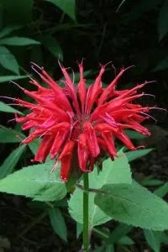
Scarlet Bee Balm
Monarda didyma

*Part-sun to part-shade
*3ft-5ft tall *Deer resistant
*Attracts hummingbirds as well
as bees and butterflies
* similar flavor to oregano
*excellent addition to herbal teas

